Project Title
Netflix Subscriber Churn Prediction Using Machine Learning
Student Name: Namrata Morarji Choudhari
Student ID: KTT/INT/2026/S193
Submission Date: 20-06-2026

Introduction
- Project Objective
The objective of this project is to predict whether a Netflix subscriber is likely to continue or cancel their subscription.
- Problem Statement
Netflix has many subscribers. Some continue their subscription while some cancel it. This project helps predict whether a subscriber is likely to cancel or continue.
- Dataset Overview
The dataset contains the following information:
- SubscriptionMonths
- WatchHours
- Logins
- Complaints
- Churn
Where:
- Churn = 1 means Cancel Subscription
- Churn = 0 means Continue Subscription

Data Preparation
- Dataset Loading
The dataset was loaded using the Pandas library.
- Feature Selection
Input Features:
- SubscriptionMonths
- WatchHours
- Logins
- Complaints
Output Feature:
- Churn
- Encoding and Scaling
No encoding or scaling was used in this project.

Model Building
Supervised Model Used
- Logistic Regression
Used to predict whether a subscriber will cancel or continue the subscription.
Unsupervised Model Used
- K-Means Clustering
Used to group subscribers based on their activity.
Why These Models Were Selected
- Logistic Regression is simple and suitable for prediction.
- K-Means is simple and suitable for grouping users.

Model Evaluation
- Churn Prediction
The Logistic Regression model predicts whether a subscriber is likely to:
- Cancel Subscription
- Continue Subscription
- User Clustering
The K-Means model groups subscribers into:
- Less Active Users
- More Active Users
based on Watch Hours and Logins.

Visualizations
Here are some previews of the project: 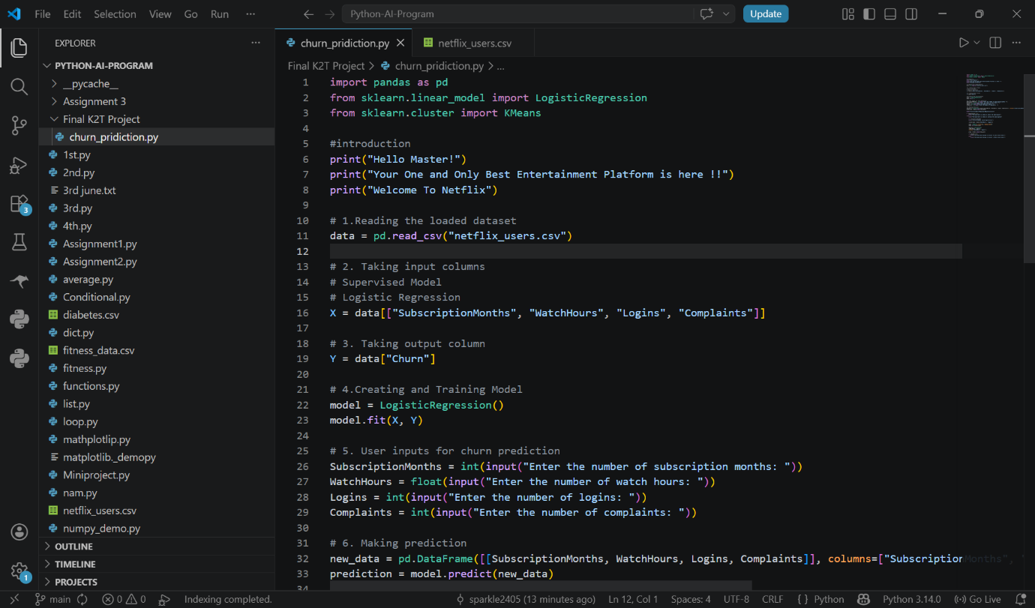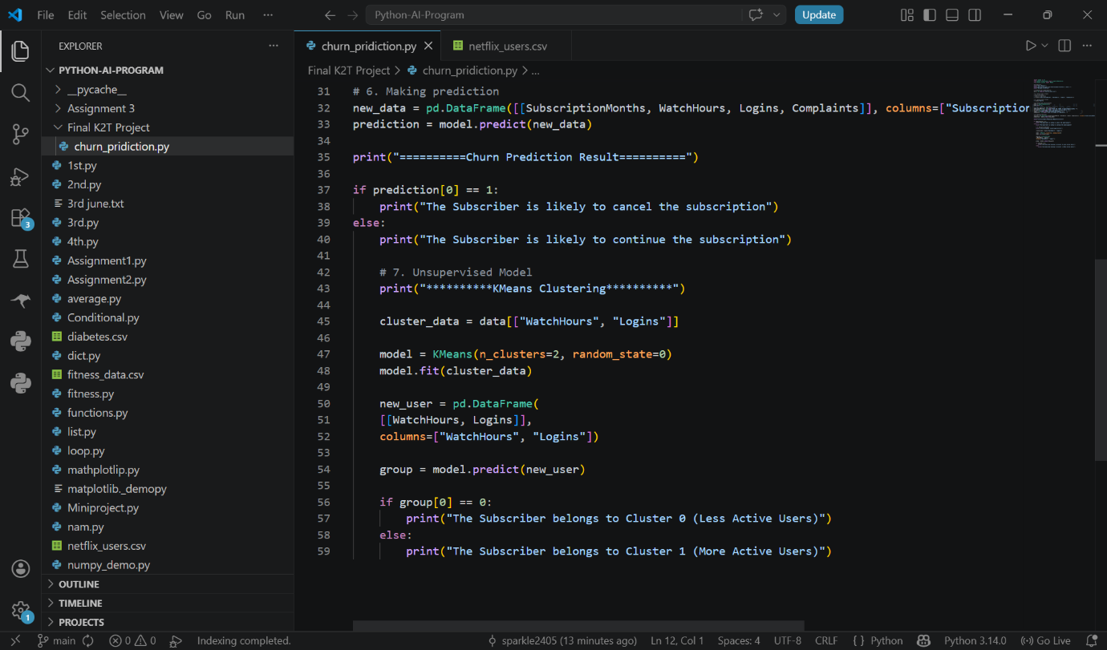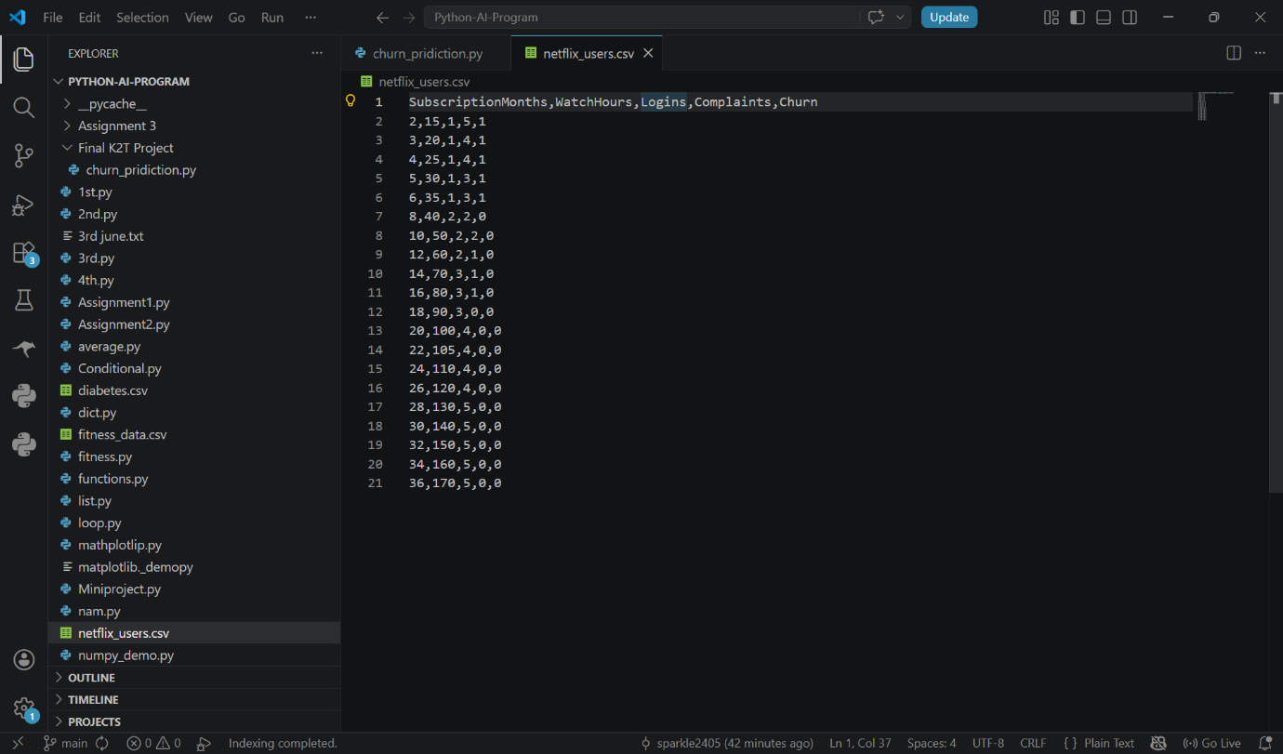
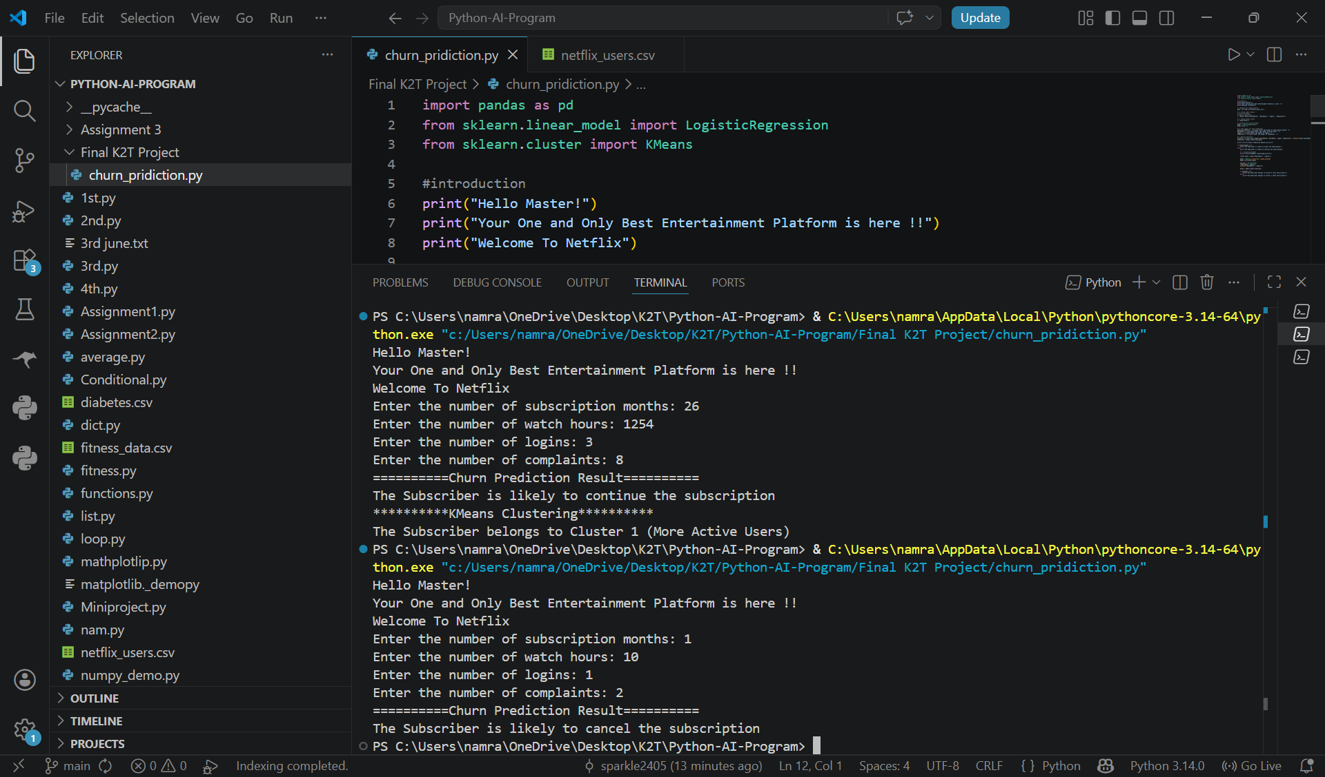

Findings
- Subscribers with more watch hours are more likely to continue.
- Subscribers with fewer complaints are more likely to continue.
- K-Means successfully grouped users based on activity.

Conclusion
This project uses Machine Learning to analyze Netflix subscriber data.
Logistic Regression predicts subscriber churn, while K-Means Clustering groups users according to their activity level.
The project shows how Machine Learning can be used to understand subscriber behavior.

